Resizing the box (will need more explanation of course)

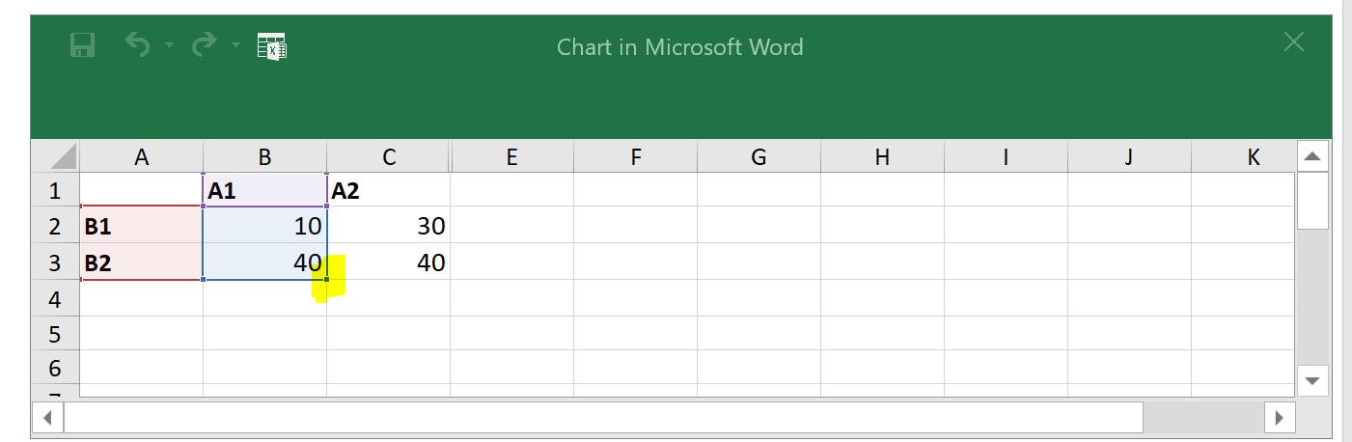resize using highlighted portion to change active data for plot

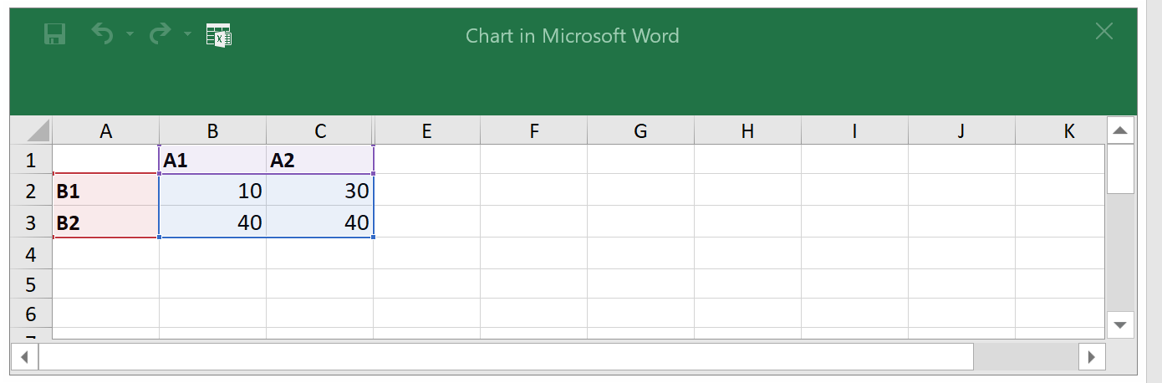

Done!